
Checked the connectivity between the servers
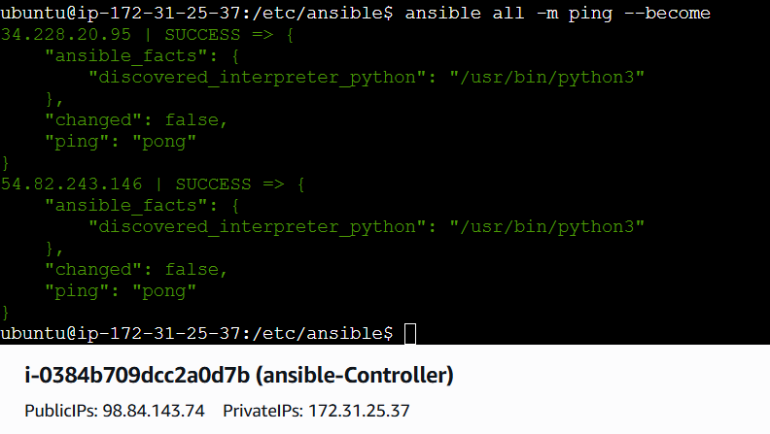
Playbooks:
Ansible playbooks are the "blueprints" of your automation. While your previous command (ansible all -m ping) was an ad-hoc command—used for a quick, one-time task—a playbook is a saved YAML file that describes a complex, repeatable sequence of actions.
Think of a playbook as a "to-do list" that tells Ansible exactly how to configure your servers from start to finish.

1. Key Components of a Playbook
A playbook is organized into a clear hierarchy:
- Play: Maps a specific set of hosts (from your inventory) to a set of tasks.
- Task: A single unit of work (e.g., "Install Nginx" or "Start Service").
- Module: The actual tool that performs the work (like apt, yum, or copy).
- Handlers: Special tasks triggered only when a change occurs (e.g., "Restart Apache only if the config file was updated").

2. Why Playbooks are Better for DevOps
As a Cloud DevOps Engineer, you use playbooks for several critical reasons:
- Idempotency: You can run the same playbook 100 times, but Ansible will only make changes if the server isn't already in the "desired state".
- Version Control: Since playbooks are just text files, you can store them in Git to track exactly who changed the infrastructure and when.
- Consistency: Deploy the exact same configuration to 500 servers simultaneously, ensuring no "snowflake" servers exist.

3. A Simple Playbook Example
Based on your earlier work, here is what a basic playbook (let's call it setup.yml) looks like:
YAML
---
- name: Basic Server Setup
hosts: all # Targets the hosts in your inventory
become: true # Runs with sudo privileges
tasks:
- name: Ping the server
ansible.builtin.ping:

- name: Install Apache
ansible.builtin.apt:
name: apache2
state: present

4. Running a Playbook
To run your playbook instead of an ad-hoc command, you use ansible-playbook:
Bash
ansible-playbook -i /etc/ansible/hosts setup.yml

Tasks:
- Install httpd using ansible playbook, use handlers,notifiers.
Objective
Automate the installation of a web server while ensuring the service is only reloaded or restarted when the configuration file is modified.

Step By Step implementation
- Create a directory named playbooks and change to that directory
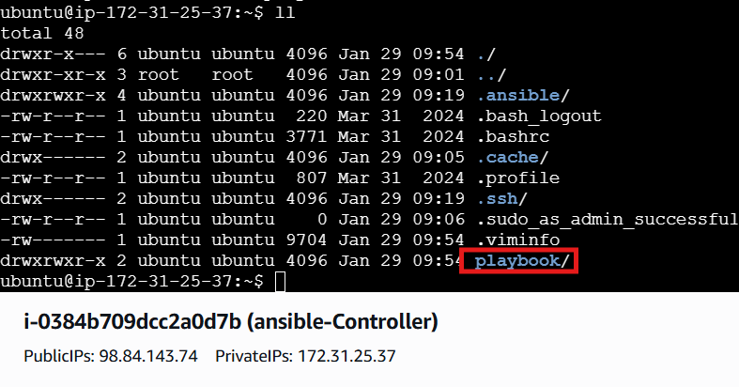
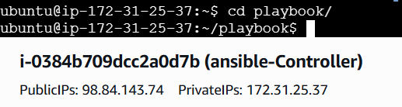

Create a index.html file inside of playbook directory and add the data into it
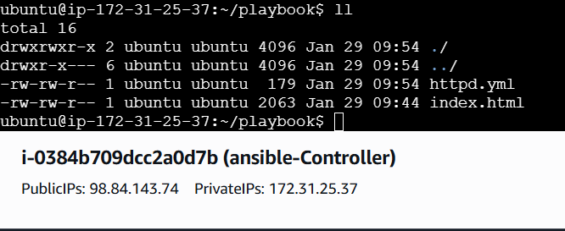
Crete a httpd.yml file and write the syntax to install apache2
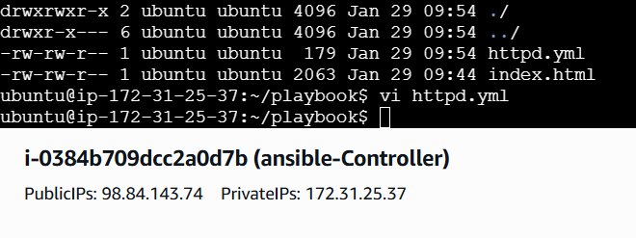
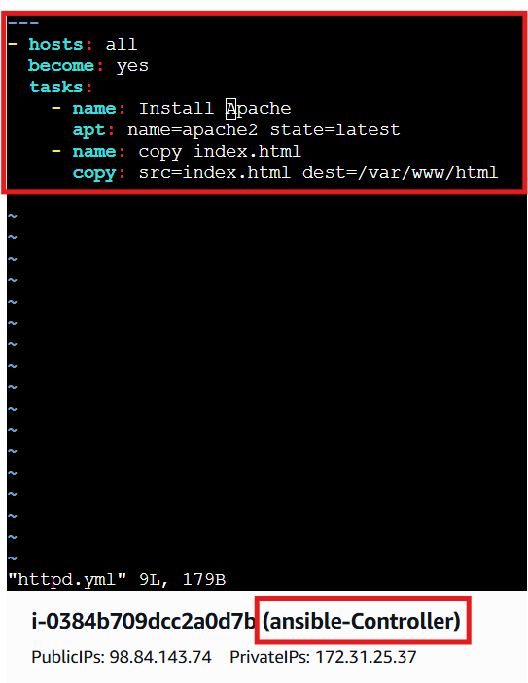
Check the syntax errors
It will list any errors if there..
Ansible-playbook httpd.yml –syntax-check
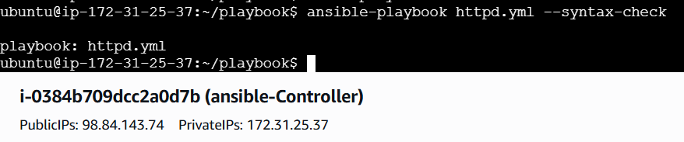
After that execute dry run using -check
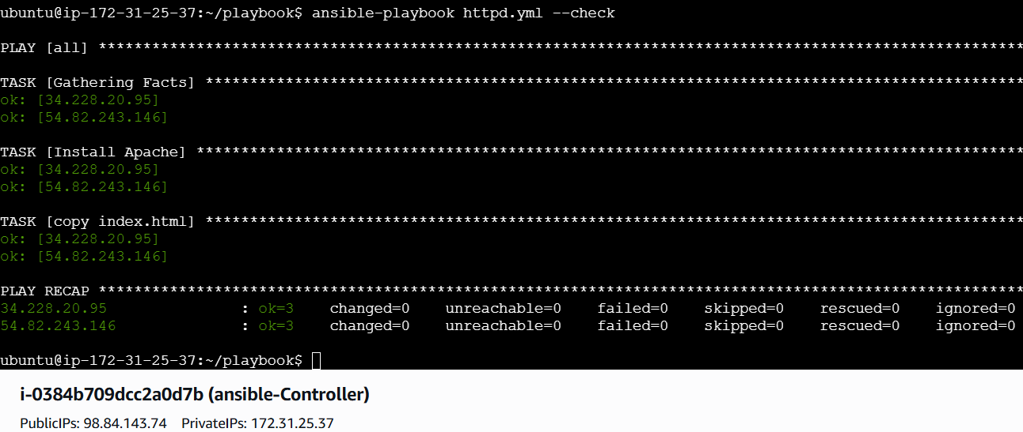

At last execute the yml file
Ansible-playbook httpd.yml
Successfully installed
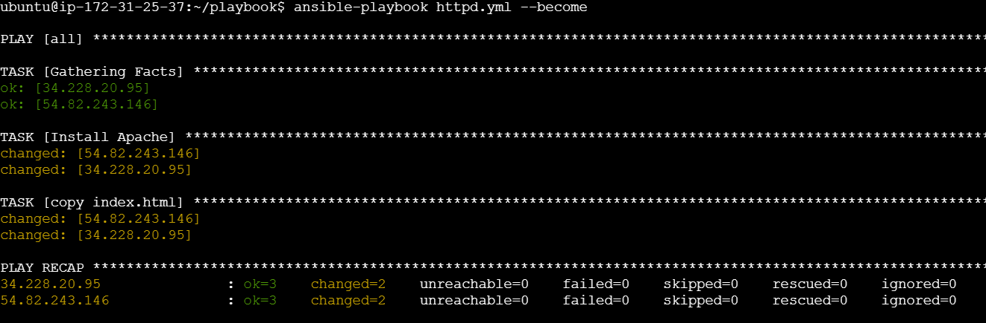

Lets verify in webserver using publicip@portnumber
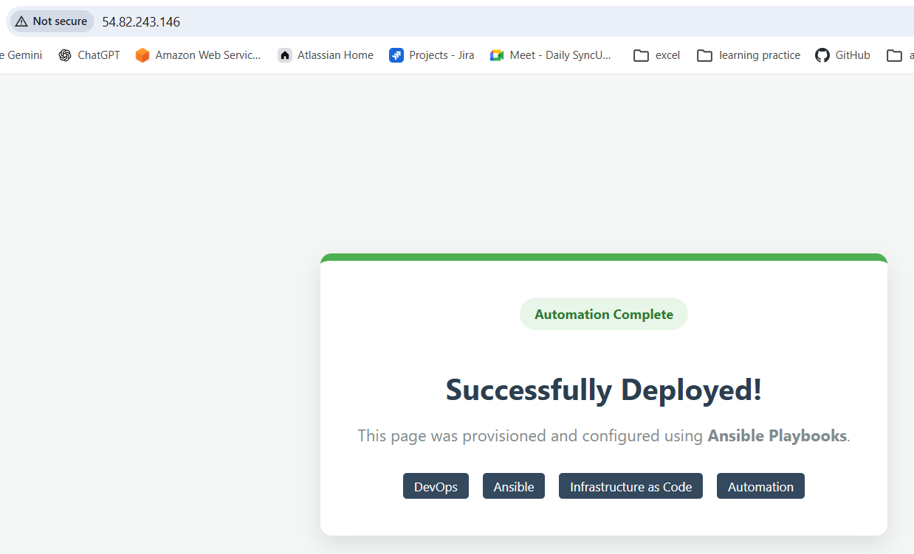in another worker machine
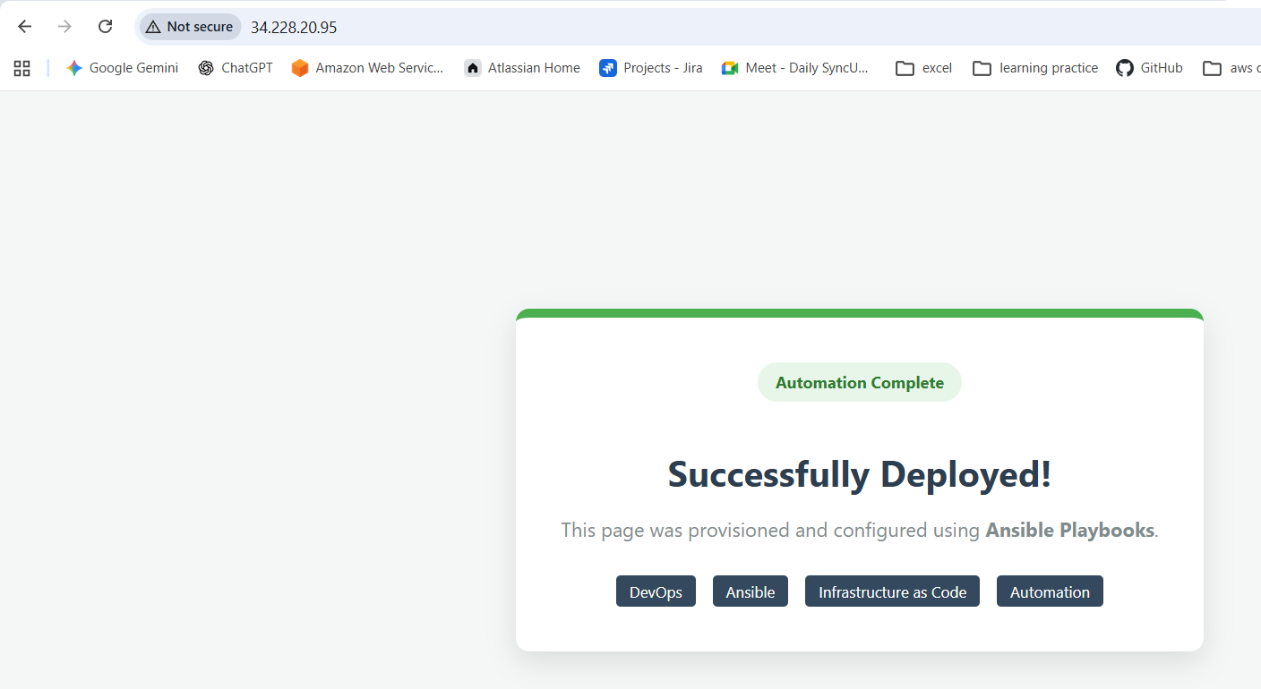

Now adding the notifiers and handlers modules and verifying them
Edit the httpd.yml file
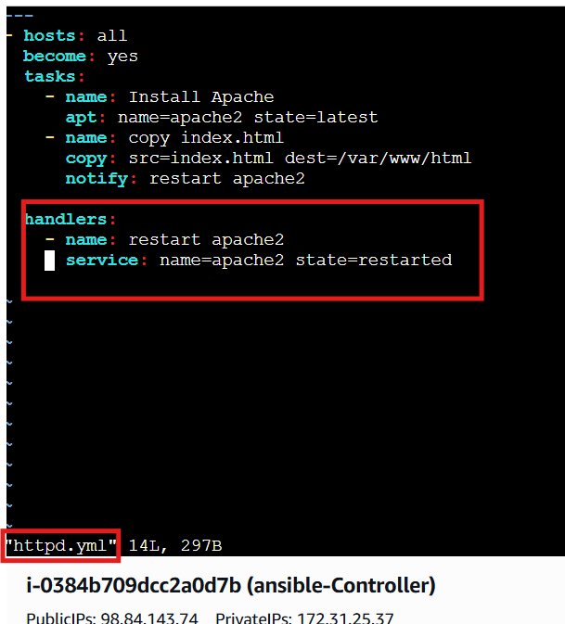

And execute dry run
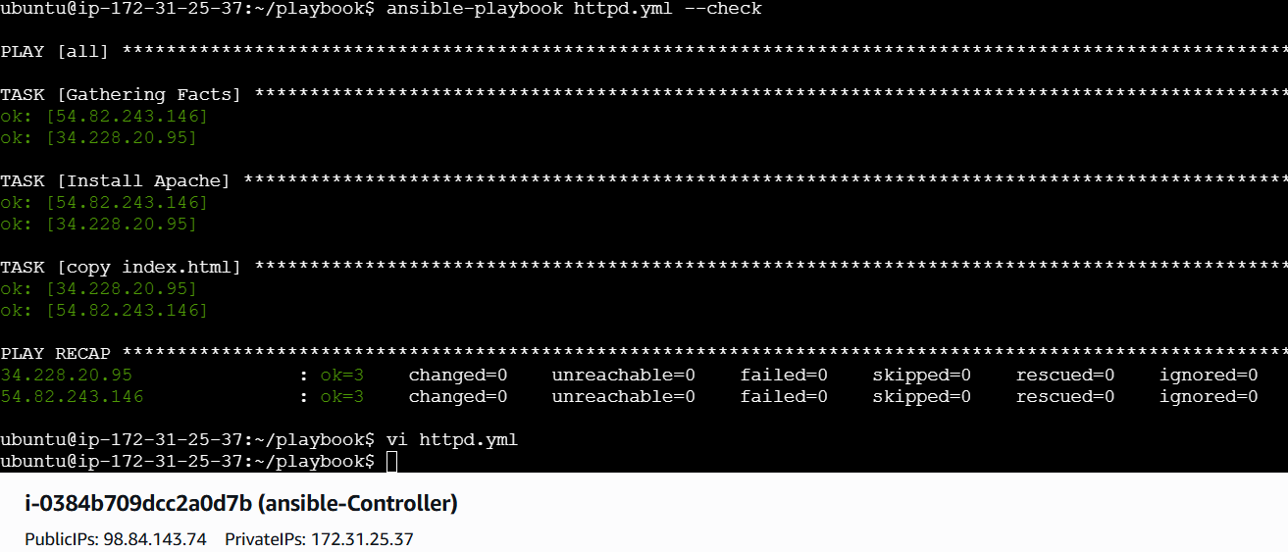

Now execute the command
In the output the servers hasn’t restarted because there is no change if there is a change then only the servers will be restarted
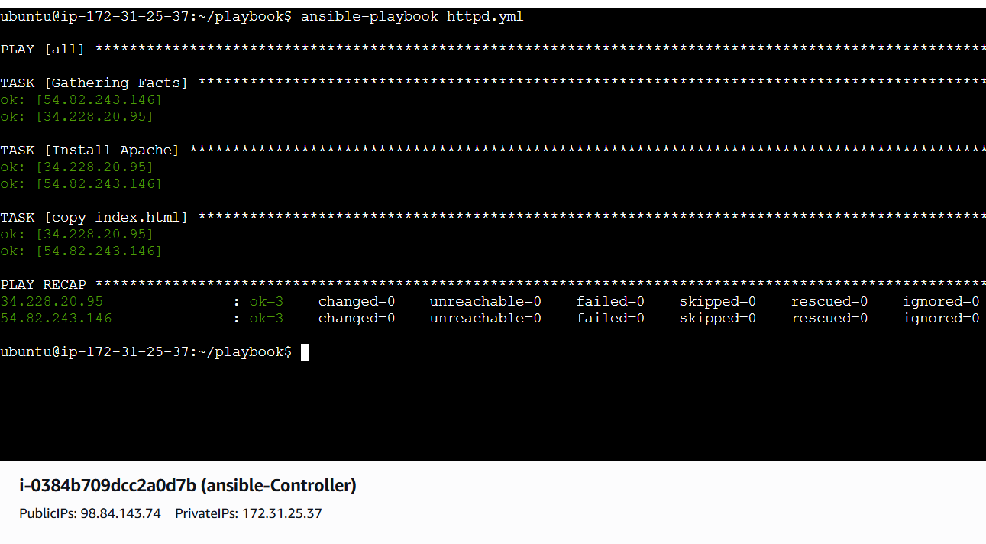
Lets make a change in index.html
And changes appeared and restarted the services
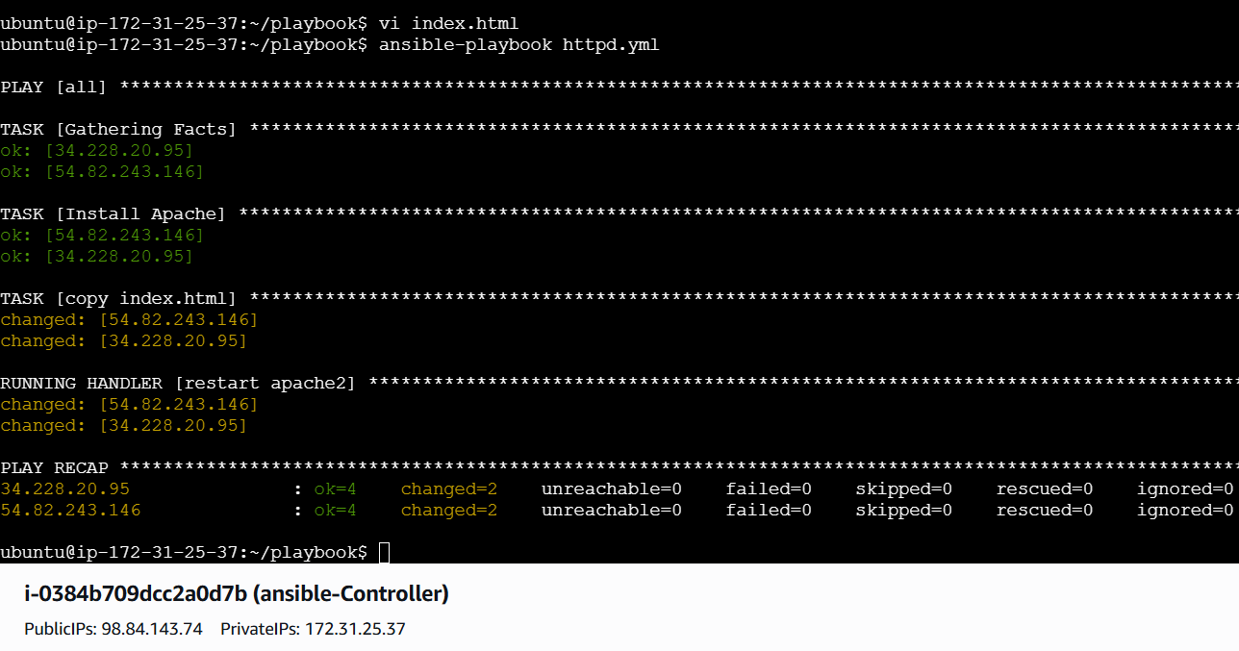

Worker 1
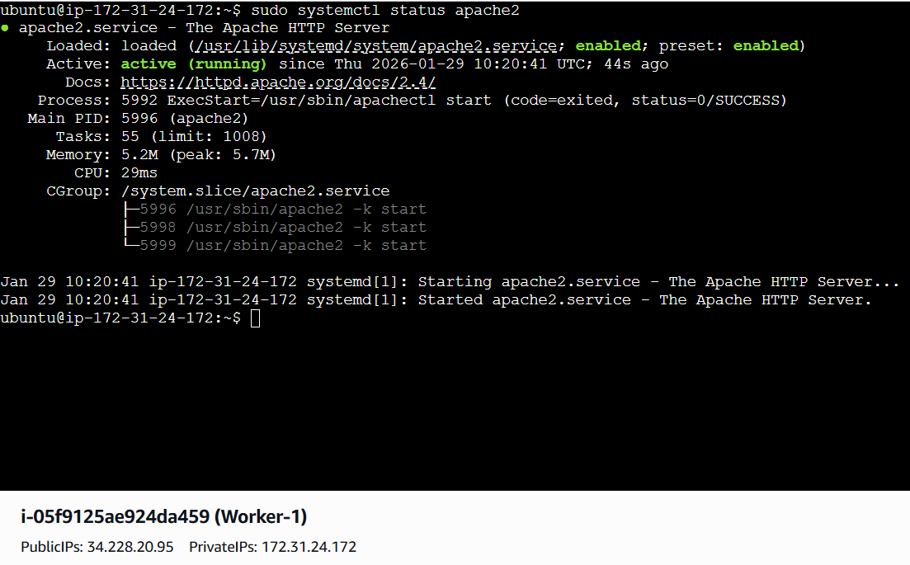

Worker 2
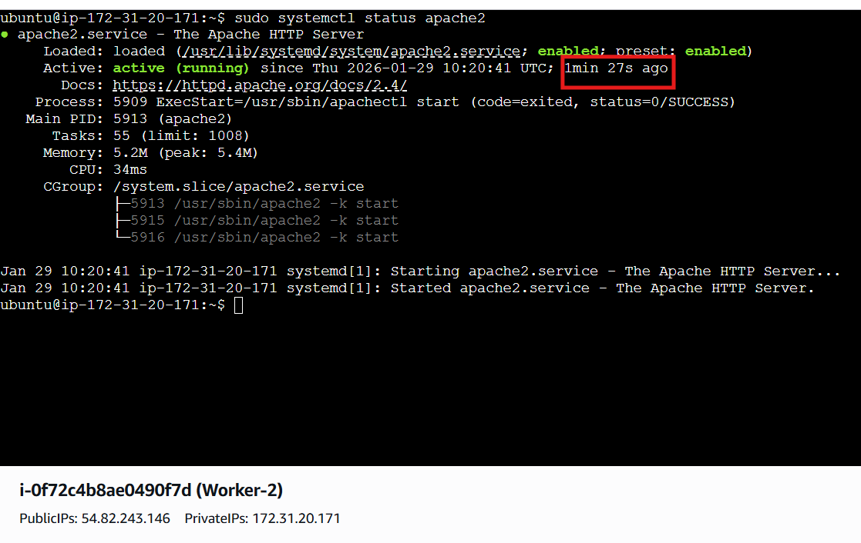

Worker 1 webpage
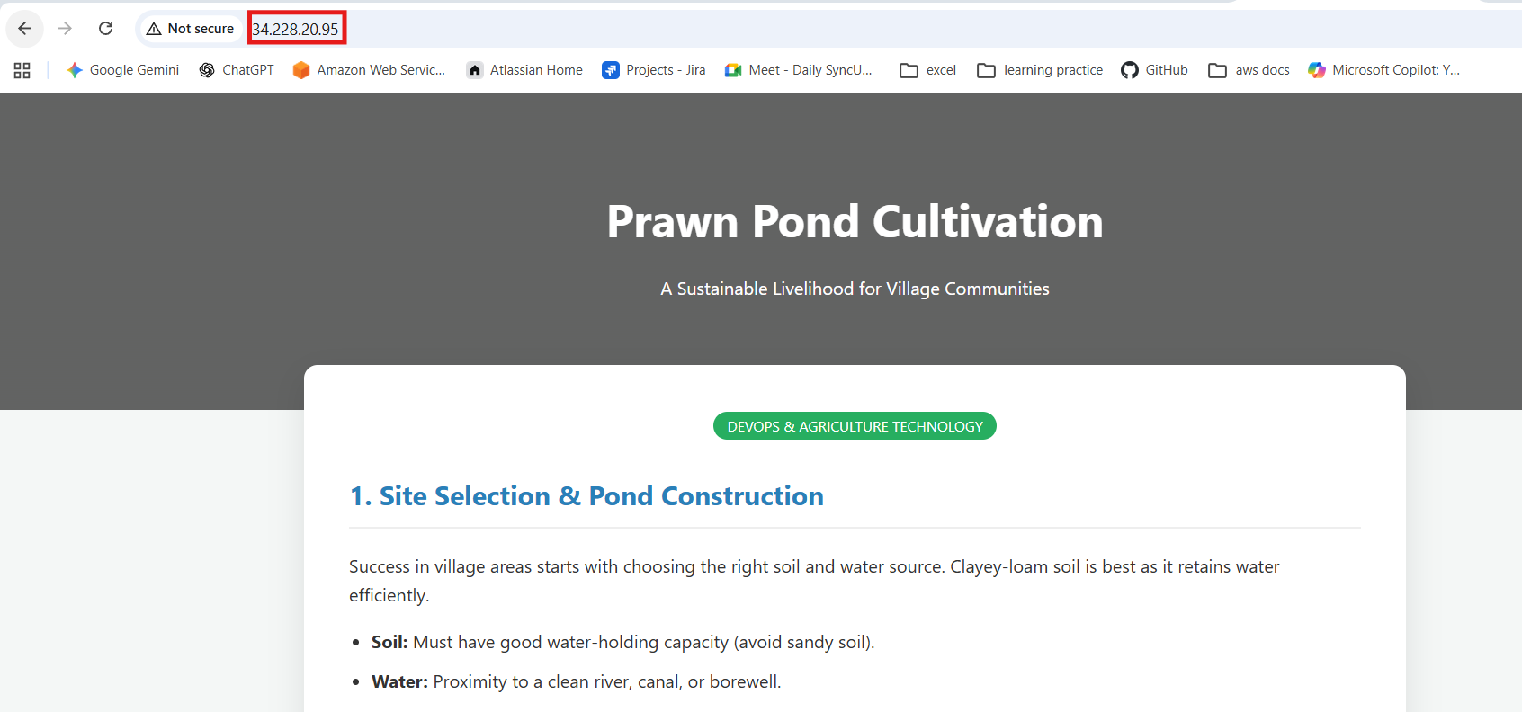
Worker 02 webpage
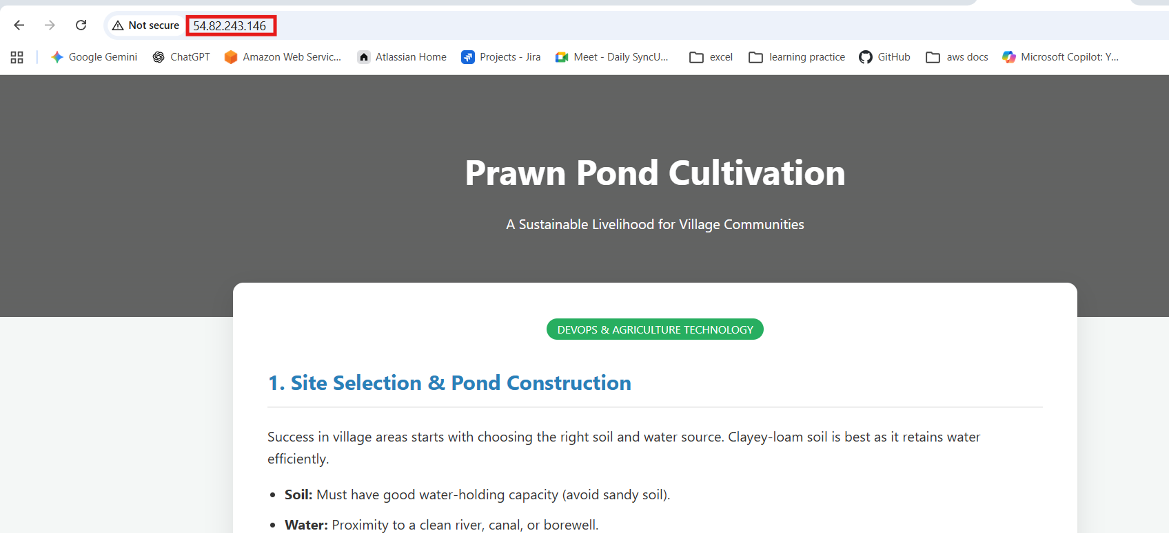
Syntax:
---
- hosts: all
become: yes
tasks:
- name: Install Apache
apt: name=apache2 state=latest
- name: copy index.html
copy: src=index.html dest=/var/www/html
notify: restart apache2

handlers:
- name: restart apache2
service: name=apache2 state=restarted
Write a ansible playbook to install apache tomcat.
Create a .yml file and execute
Syntax:
---
- hosts: all
become: yes

tasks:
- name: Install Java
apt:
name: openjdk-11-jdk
state: present
update_cache: yes

- name: Download Tomcat
get_url:
url: https://archive.apache.org/dist/tomcat/tomcat-9/v9.0.85/bin/apache-tomcat-9.0.85.tar.gz
dest: /tmp/tomcat.tar.gz

- name: Create Tomcat directory
file:
path: /opt/tomcat
state: directory

- name: Extract Tomcat
unarchive:
src: /tmp/tomcat.tar.gz
dest: /opt/tomcat
remote_src: yes
extra_opts: [--strip-components=1]

- name: Start Tomcat
shell: /opt/tomcat/bin/startup.sh

for the above task I installed java version 11
and also performed the dry run
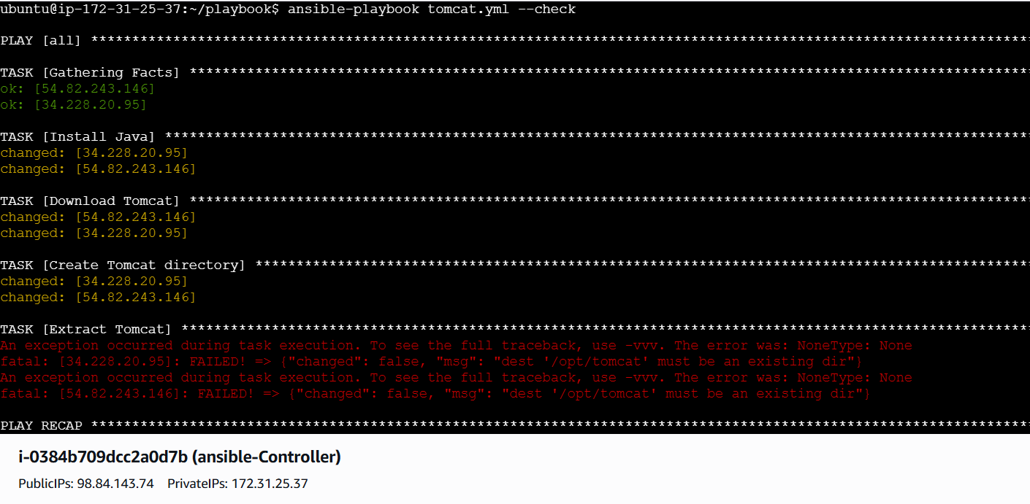
The error is it is not finding any /opt/tomcat file.. the file will created after installation of tomcat so that execute the command and it will be succeeded

After that I initiated the execution part
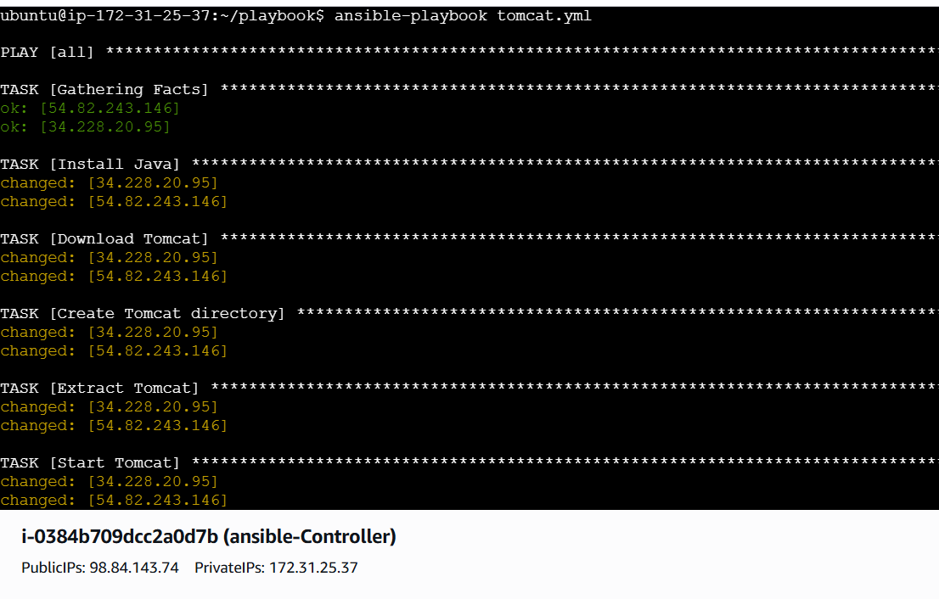
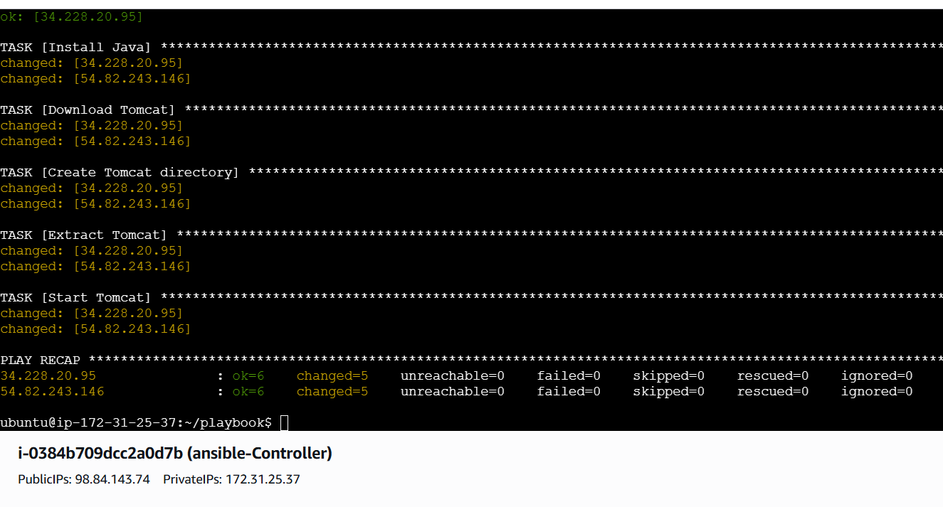

Verifying in webservers
Worker 1
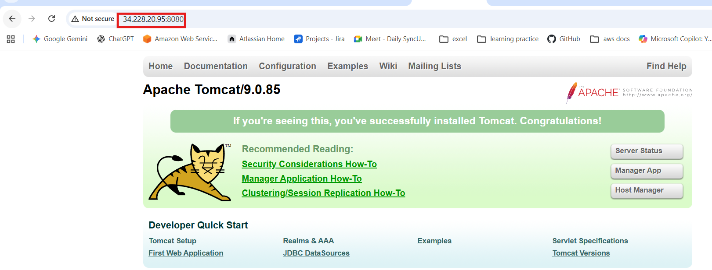
Worker 02
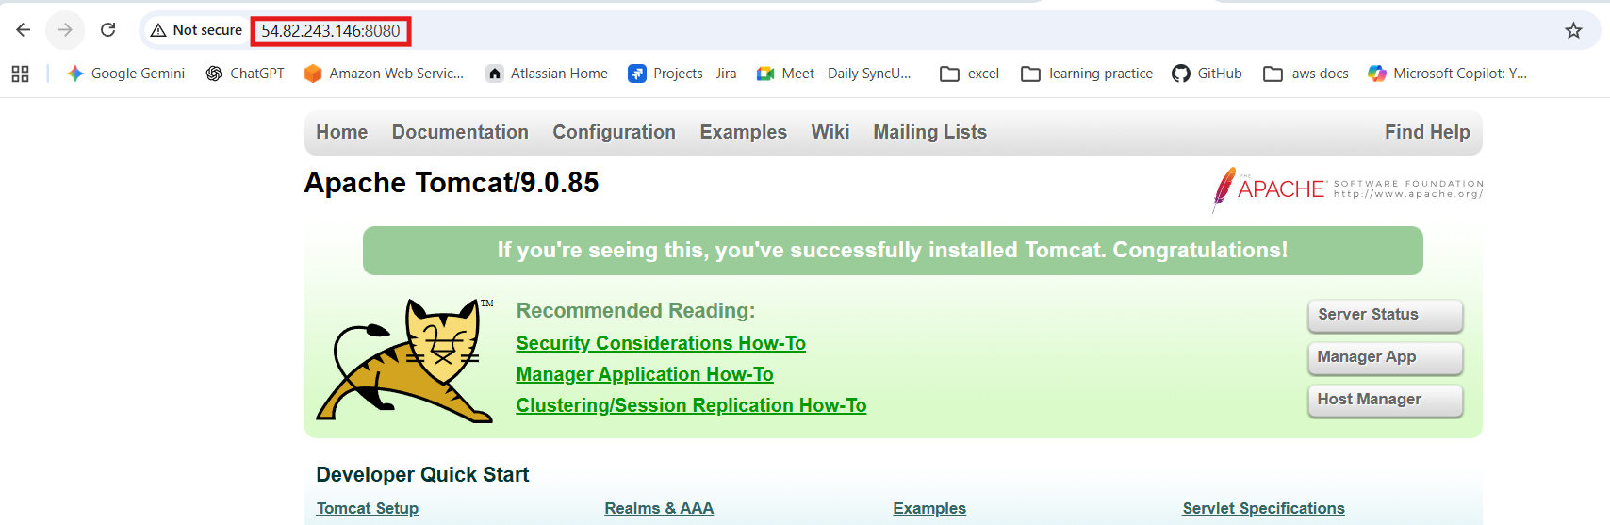

Write a ansible playbook to provision one ec2 on aws.
Create a file with .yml extension and paste the syntax:
Requirements
Need to configure aws cli so that install the following commands to get the packages
apt update
apt install unzip curl -y
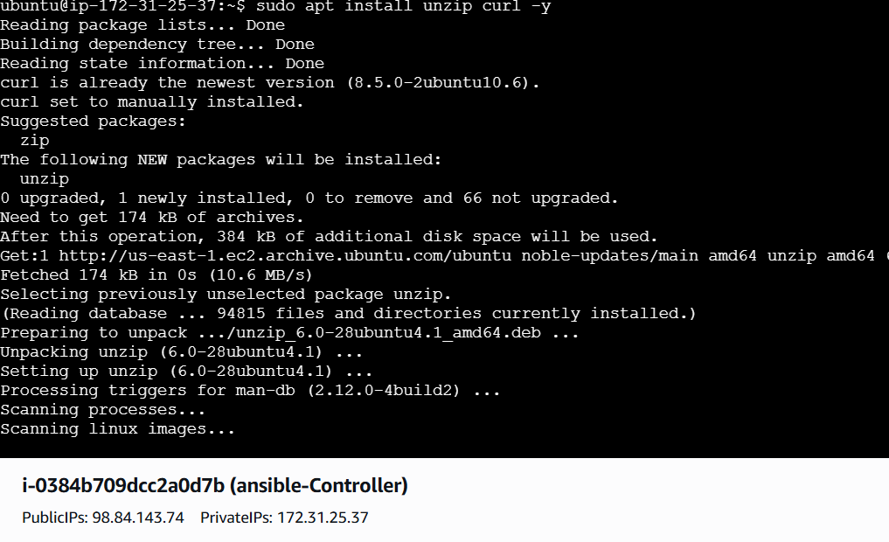
Download aws cli v2
curl "https://awscli.amazonaws.com/awscli-exe-linux-x86_64.zip" -o awscliv2.zip
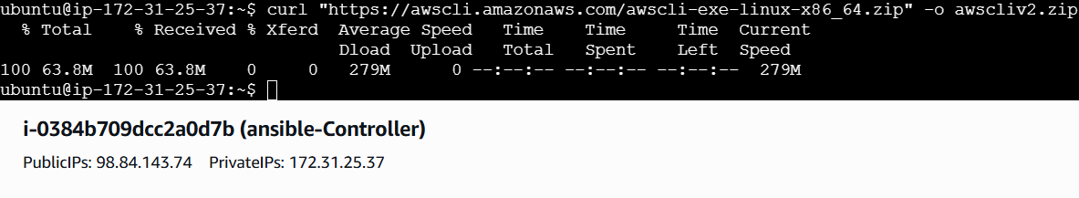

Unzip the downloaded file unzip awscliv2.zip
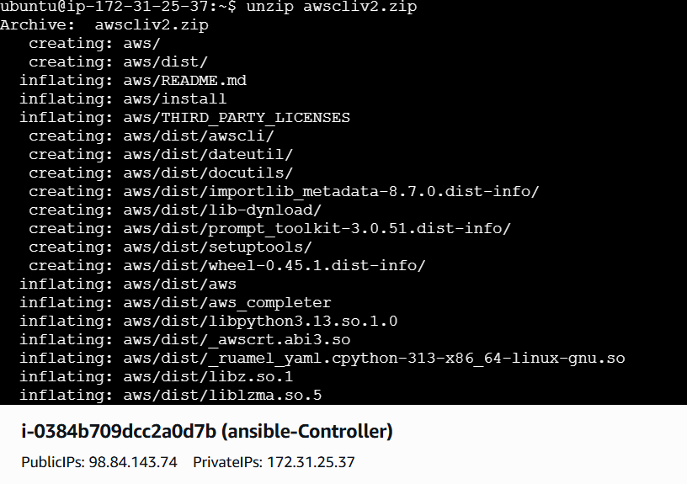
Then Install
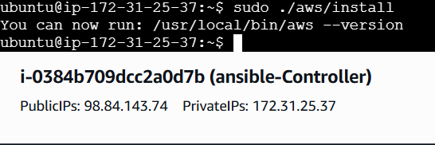
Also verified the version using aws --version
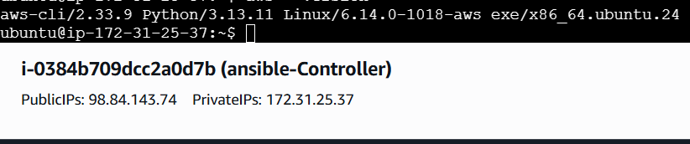

Generate credentials in aws and provide them in vm in aws configure
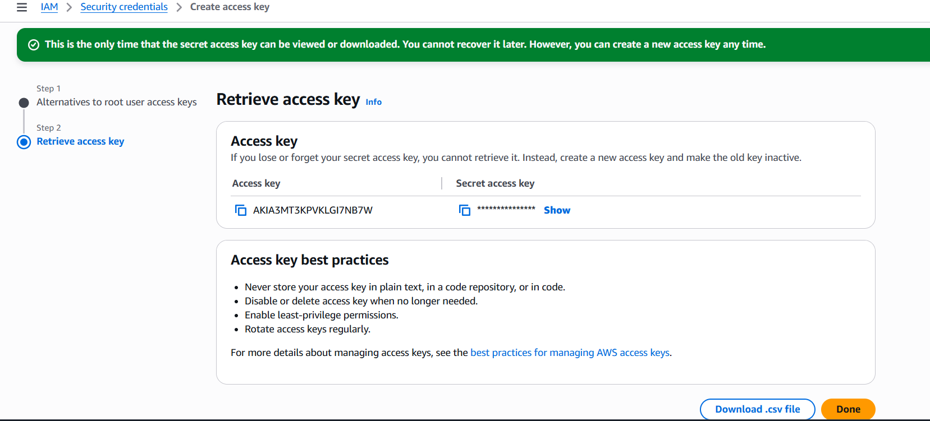
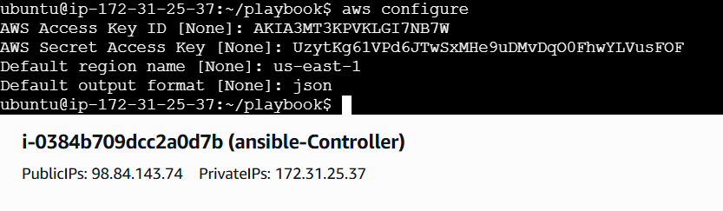
Then create a yml file and paste the syntax:
---
- hosts: all
connection: local
gather_facts: no

tasks:
- name: Create EC2 instance
amazon.aws.ec2_instance:
name: ansible_server
region: us-east-1
instance_type: t3.micro
image_id: ami-07ff62358b87c7116
key_name: sshless
security_group: default
wait: yes
and save the file
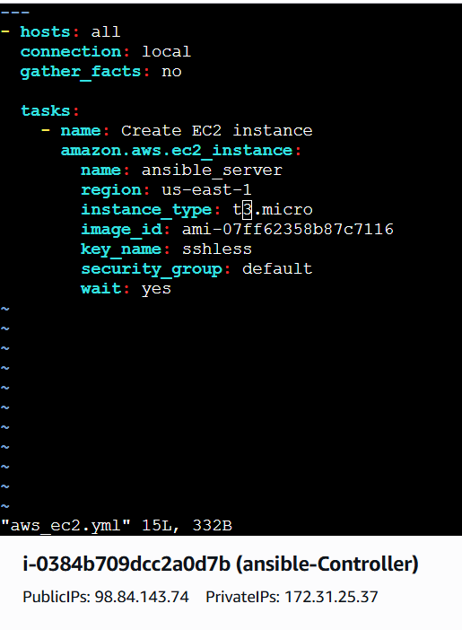
After that execute the commands
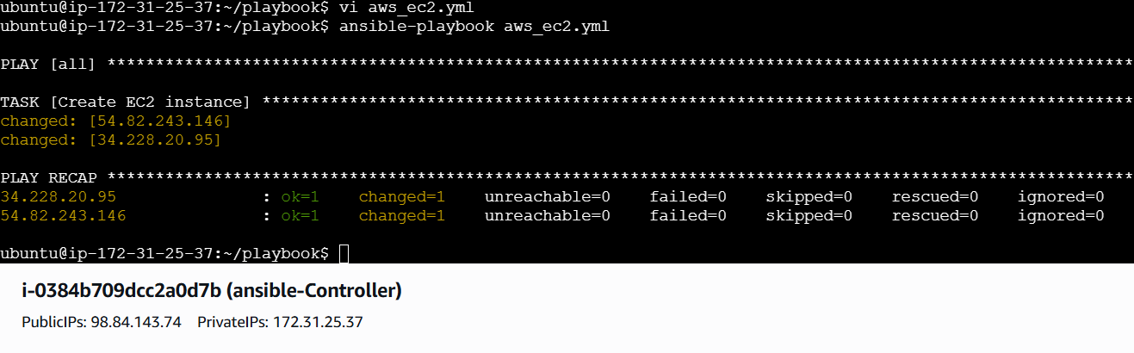
Ec2 instance has been launched
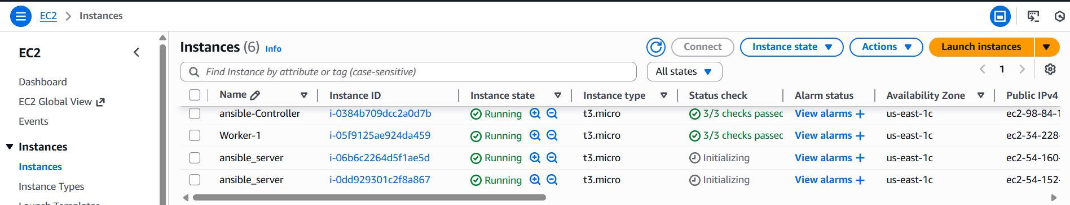

Write a ansible playbook to copy one file from node-1 to node-2.
To create one dummy file on worker01 run below command from Controller
ansible worker01 -m shell -a "echo 'Hello from worker01' > /tmp/test.txt"
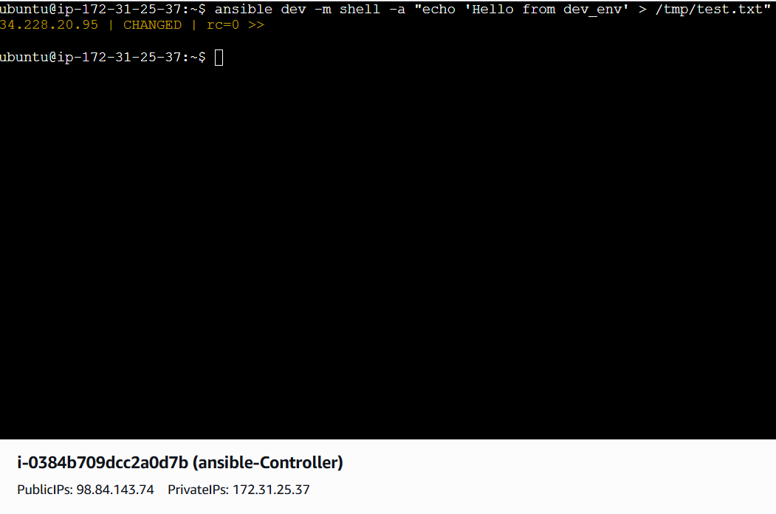

Verify the file in worker01
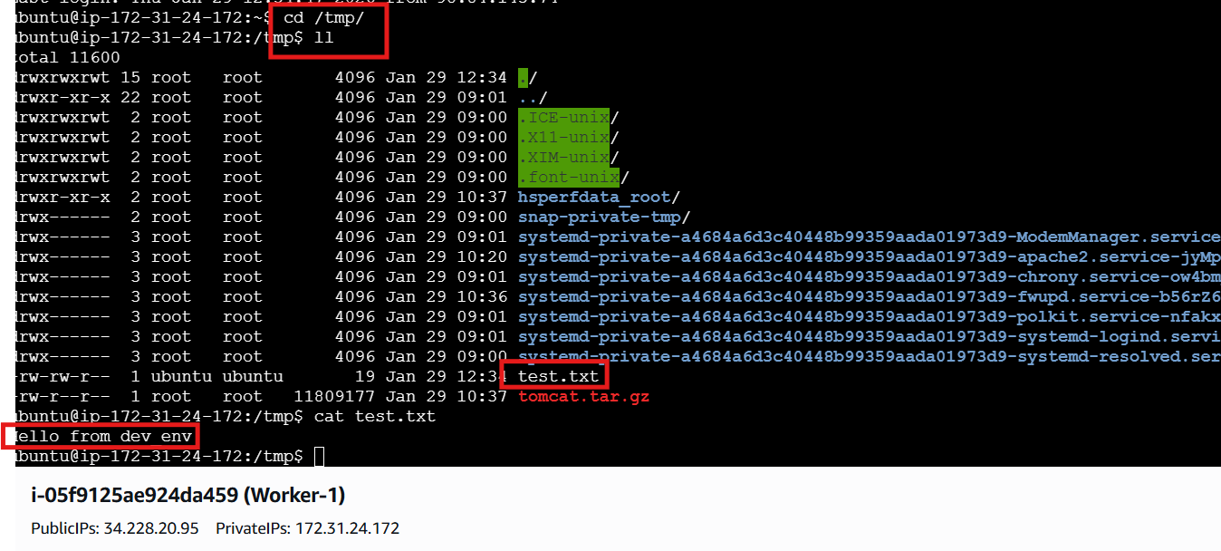
In ansible controller create a yml file and paste the syntax: Change the workernames accordingly to hosts file
Mine is dev and prod
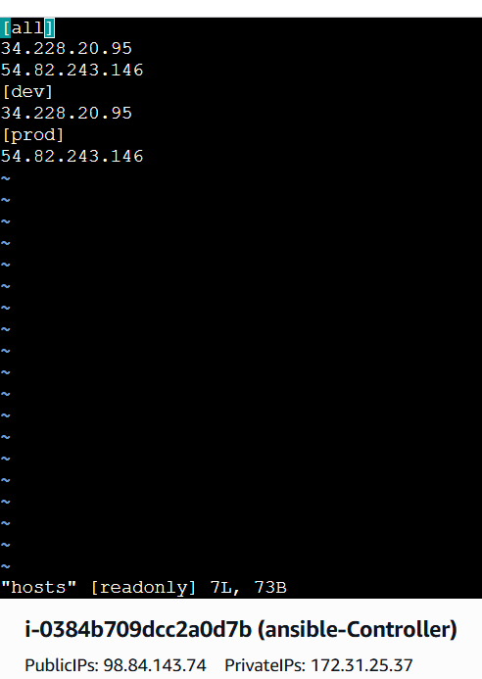
Syntax:
- hosts: worker01
become: yes

tasks:
- name: Fetch file from worker01
fetch:
src: /tmp/test.txt
dest: /tmp/test.txt
flat: yes

- hosts: worker02
become: yes

tasks:
- name: Copy file to worker02
copy:
src: /tmp/test.txt
dest: /tmp/test.txt

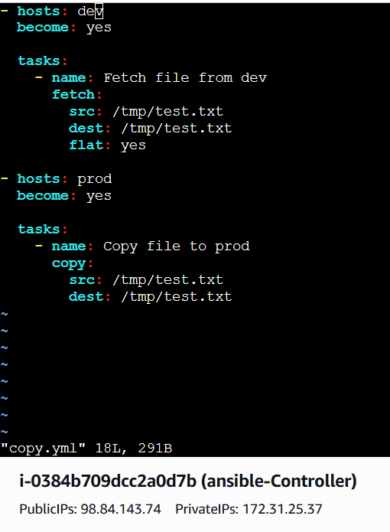
Then execute the commands verify the file in worker 2
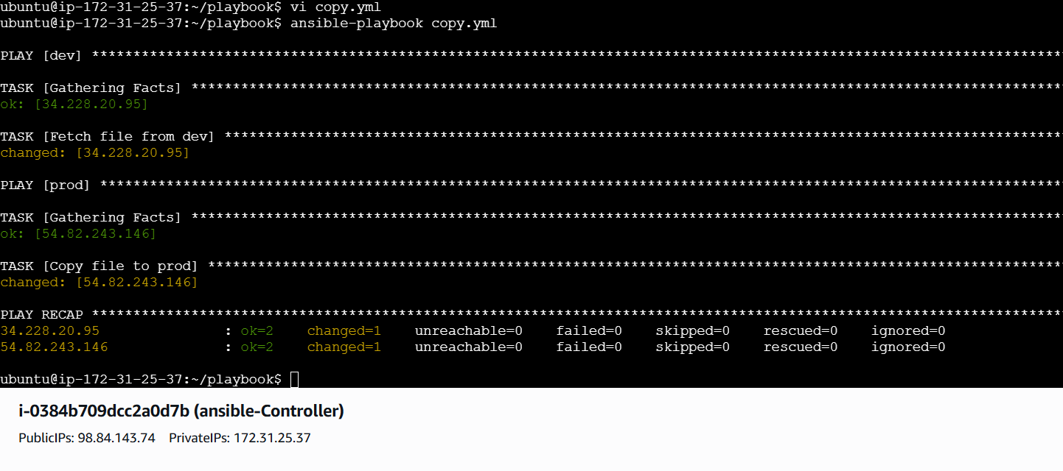

File has been copied successfully
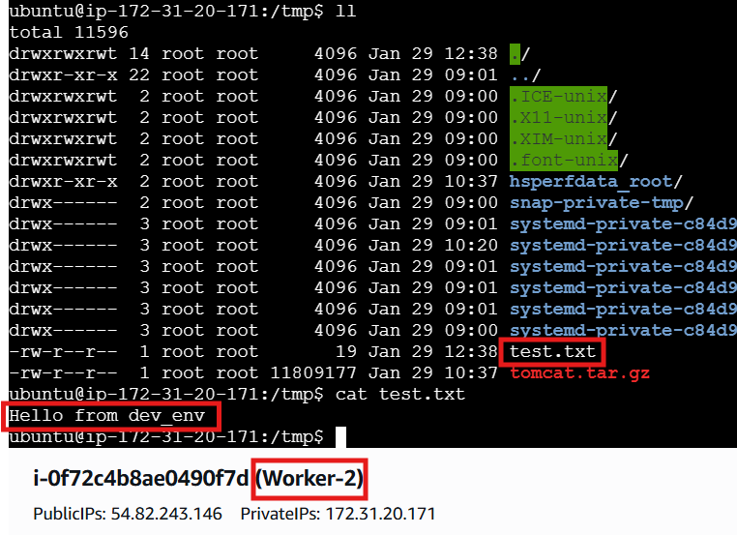

Write a ansible playbook to create different files with different names using single playbook.
Create a yml file in controller and paste the syntax:
Syntax:
- name: Create multiple files
hosts: all
become: yes

vars:
files:
- dev.txt
- test.txt
- prod.log

tasks:
- name: Create files
file:
path: /root/{{ item }}
state: touch
loop: "{{ files }}"
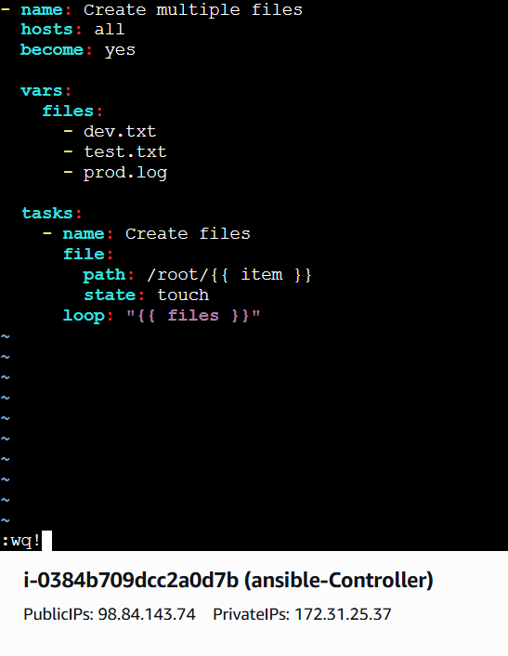

Successfully created the files form controller
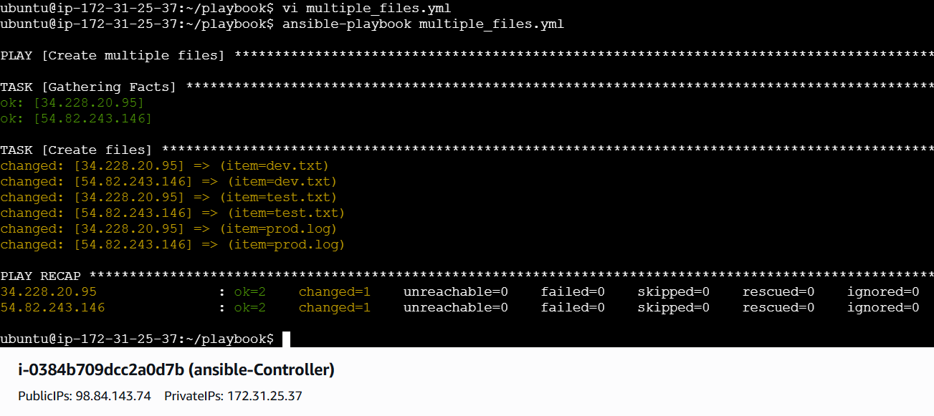
Lets validate in workers
